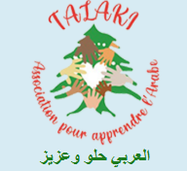
HSK-Unterricht Arabisch

Informationen:
Association Talaki - Learn Arabic Easily and Effectively

Anmeldung:
Association Talaki - Learn Arabic Easily and Effectively

